PLC TO USR W610 SETUP AND CONNECTION(IOT PROJECT)
OVERVIEW:
USR-W610 is a serial(RS485/RS232) to WiFi/Ethernet converter. The data from the PLC is transmitted through RS485/RS232 protocol to the USR-W610.This can be done by MODBUS/TRANSPARENT mode depending on use case.
The register(or the range of registers) whose data is to be transmitted is to be noted .
Hardware Connection:
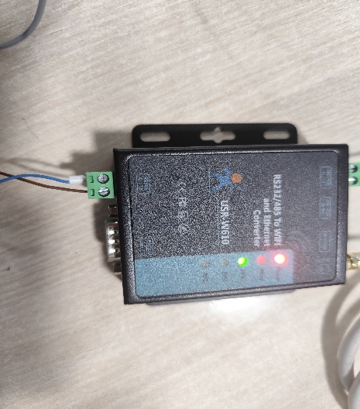
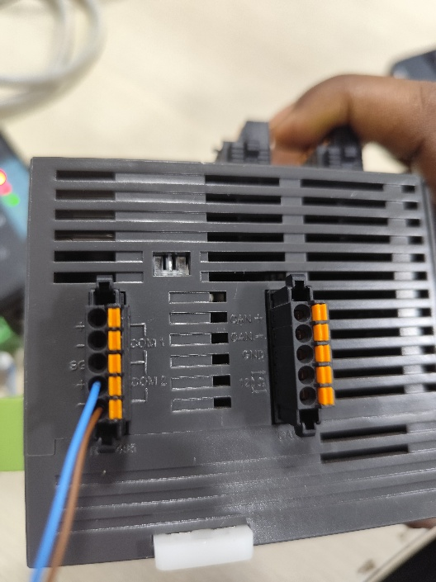
Connect both the PLC and the USR-W610 to a 24V POWER supply. (USR W610 power supply range is from 5V-36V).

The RS485 communication ports of the PLC are its COM2 ports. Connect the ‘+’ of the PLC to the ‘A’ of the USR-W610 and ‘ - ’ of the PLC to the ‘B ’ of the USR-W610.

USR-W610 WORKING CONDITIONS:
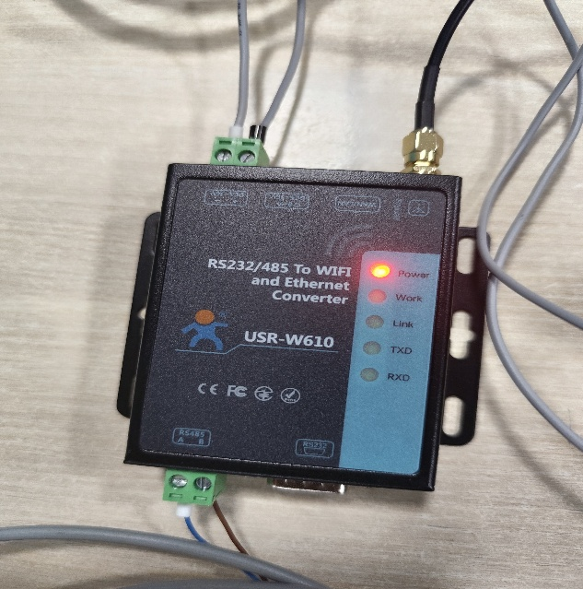
POWER ON:

Power ON LED glows when proper power supply(5-36V)is given.

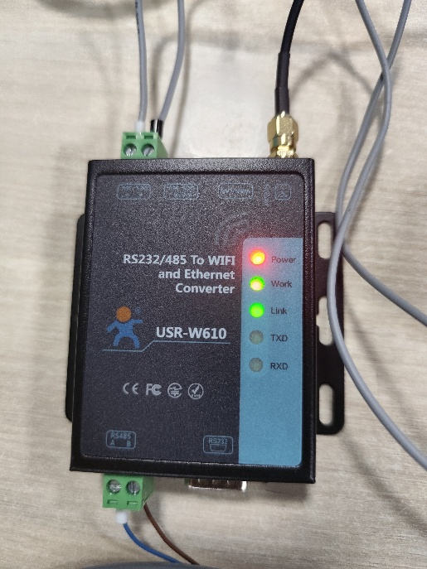
WORK :

WORK LED starts to blink if the device has no issues, during reset or after rebooting LED glows for a complete second before blinking .

Working LED blinks every second to indicate the USR is in perfect working condition.
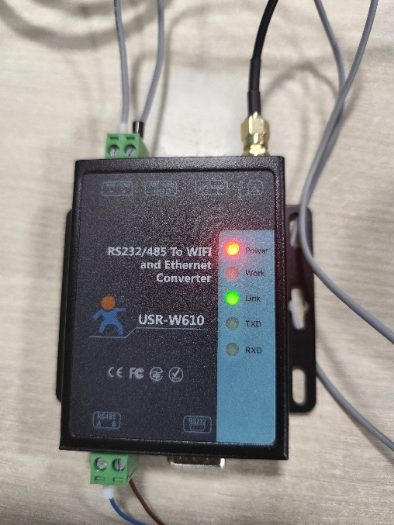
LINK:

If a USR-W610 establishes a successful connection LINK led glows.

TX AND RX :
If data is received successfully RX led blinks,if data is transmitted successfully TX led blinks.The rate at which it blinks depends on the polling interval(interval at which data is repeatedly requested and sent).

CONFIGURATION OF PLC:

CONFIGURATION AND SETUP OF USR-W610:
1.Initial Setup:
- Press the reset button near the antenna of the USR-W610 to configure its settings from the start.
- After the reset is pressed, the USR creates its own Wi-Fi named USR-W610 ,Connect to this Wi-Fi.
- To configure its settings, Go to the browser and type: 10.10.100.254
- The username and password will be admin, admin.
2.AP/STA MODE:
2.1 AP MODE-Access Point Mode:The USR-W610 creates its own WiFi which the other devices should connect to,for accessing data(or this mode is used for configuration purpose also).
2.2 STA MODE-Station Mode:The USR-W610 connects to a specific WiFi(network) as configured in its settings,for transmitting data.
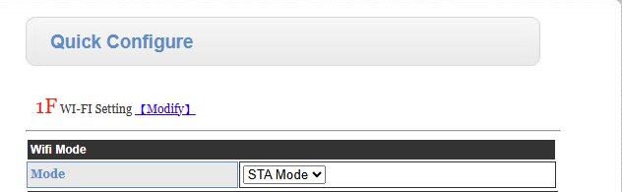
USR W610 can be run in AP or STA or in AP+STA modes. For the use case go with STA mode so it can connect with the already existing WiFi of the industry/department to transmit data over that WiFi.

3 .Connect to the WiFi you are going to use for transmission.
AP’SSID is the Wifi’s name and KEY is the password of that Wifi.
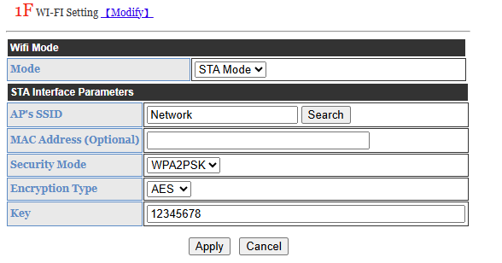
4.UART SETTINGS:
4.1ModBus RTU :Is the protocol used in transmission of serial data from PLC to USR-w610
4.2ModBus TCP: Is the protocol used in transmission of data through WiFi/Ethernet.
Modbus tcp Modbus RTU is used so that we can check if the data is getting transmitted.
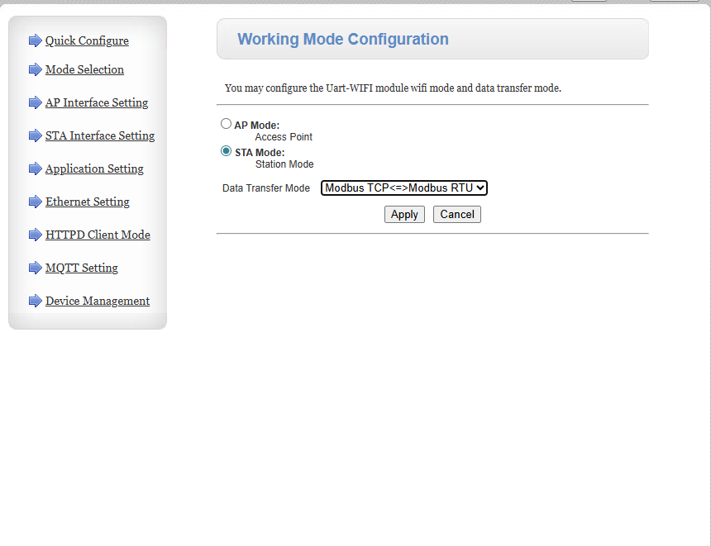

In this data transfer mode we need a pc (a master device) to poll the USR ,and specifically we use MODBUS POLL application running in that master device.

5.STA INTERFACE:
5.1WAN Connection Type:
5.1.1We use STATIC mode to get a fixed IP even in the case our USR resets .
5.1.2 If we use DHCP config ,each time USR reconnects to the WiFi our IP changes which may become difficult to when we create a connection to the web-dashboard
(or even while connecting to the master device).
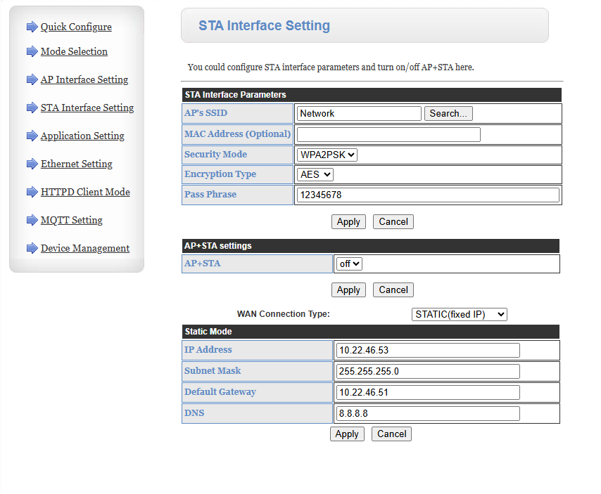
5.2 Change the IP Address ,subnet mask and gateway for the WiFi you are going to connect.
5.2.1 Connect to the WIFI you want to connect the USR W610 from PC
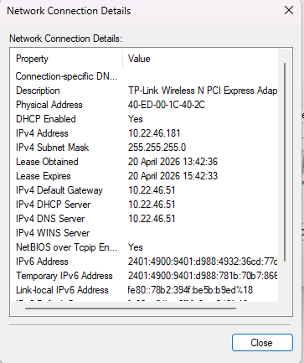
5.2.2 Search for VIEW NETWORK CONNECTIONS from the settings of PC ,click WIFI -> DETAILS:

5.2.3 Copy the subnet mask and IPV4 DEFAULT GATEWAY as such from here to USR W610.For IP just change the IPV4 ‘s last digits and enter in USR.(Here the ipv4 address is 10.22.46.181 , changed to the 10.22.46.53) : Devices connected to the same network has address in the format 10.22.46.xx ,only the last digits change from 0 to 255,each indicates a different device.
5.3 DNS: To use MQTT Brokers through internet assign a DNS. Here 8.8.8.8(google’s Dns ) is used .This DNS can be used for most default cases. If the transmission takes place through WiFi without the need for internet leave it empty.

6.Application Settings:
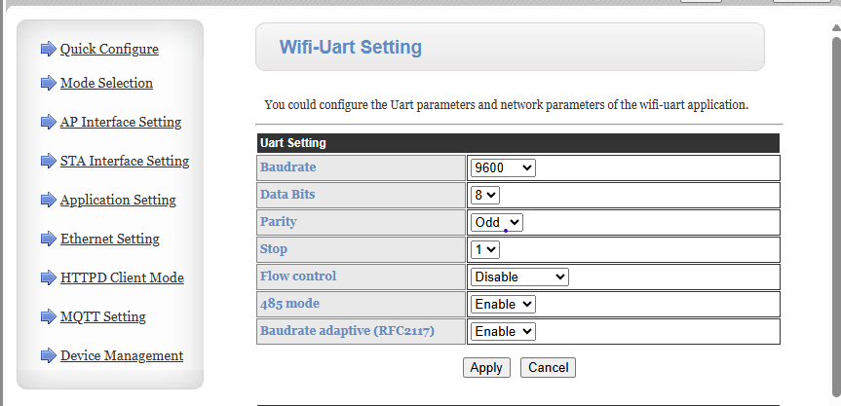
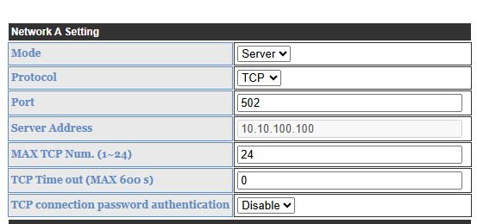
Change the settings(BAUD RATE,DATA BITS,PARITY ,STOP BITS),as previously SET in your PLC.

In network settings set the port to 502 .

7.Device Management :
7.1 APPLY all the changes made before.
7.2 REBOOT to save the configurations to USR W610.
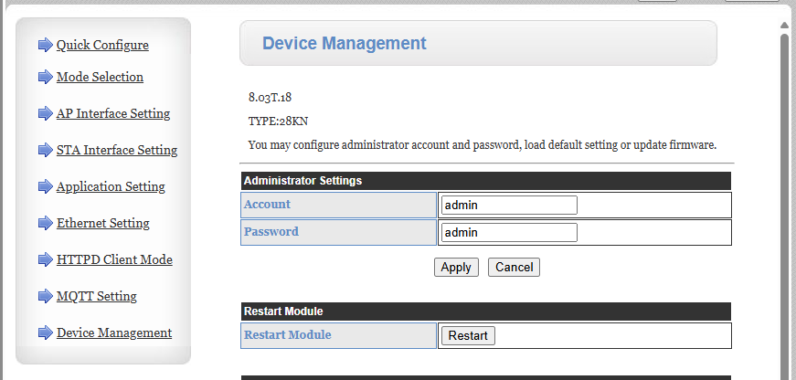

8.OUTPUT IN MODBUS POLL
8.1 Open MODBUS POLL:
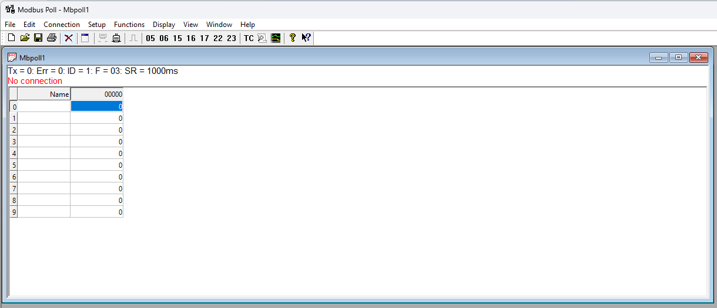
8.2 Add a new connection:
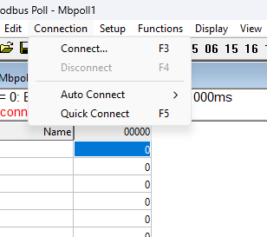

CLICK Connections->Connect
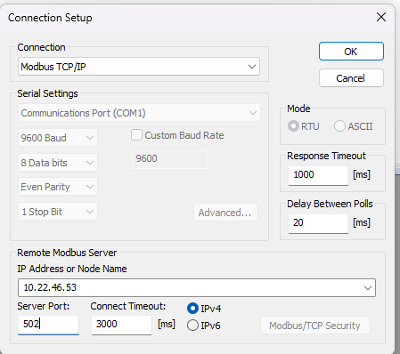

Enter the Ip Address and server port already configured in USR W610.

8.3 Add Read/Write Definitions:
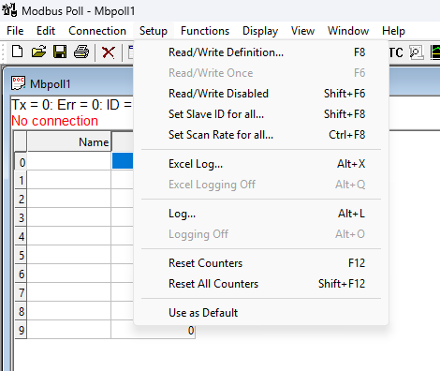
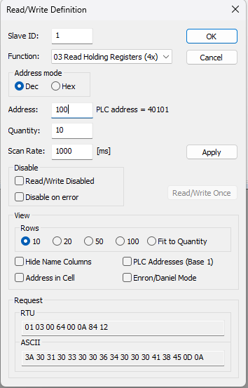

CLICK Functions->READ/WRITE definitions.

8.3.1: SLAVE ID: By default 1,if more than 1 slave connected to the PC(master device) enter the appropriate slave id.
8.3.2 The address is the register address whose data is set to be transmitted .If the register is D100 give input as 100.
8.4 If the output is received correctly continue with the next steps .

9. CONFIGURATION OF USR-W610 FOR WEB-DASBOARD DATA TRANSMISSION USING MQTT(HIVEMQ) BROKER.
9.1 MQTT: MQTT is a simple way for devices to talk to each other through a middleman. Instead of devices communicating directly, they send messages to a central broker, which then distributes those messages to the devices.
- Publisher: A device that sends data (e.g., a temperature sensor)
- Subscriber: A device or app that receives data (e.g., a dashboard)
- Broker: The server that manages message delivery
- Topic: A label for messages (e.g., home/livingroom/temperature)
Quality of Service (QoS) levels
MQTT lets you choose how reliably messages are delivered:
- QoS 0: At most once (fastest, no guarantee for data reception some data packets may get lost)
- QoS 1: At least once packets are sent. (may duplicate)
- QoS 2: Exactly once (slowest, safest)

9.2 To create a web-based dashboard for the values we just sent over Modbus poll ,we use a option called MQTT in USR-W610 and connect it with a MQTT broker like hivemq.
9.2.1 Change the Mode from MODBUS TCP MODBUS RTU to Transparent, as data is transferred through a MQTT broker not through a MODBUS RTU protocol.
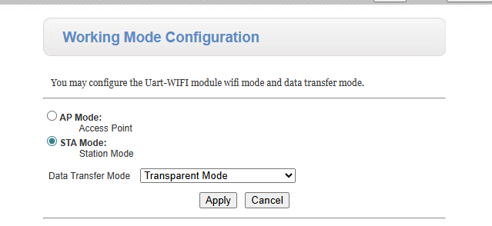

9.3 WIFI –UART SETTINGS:
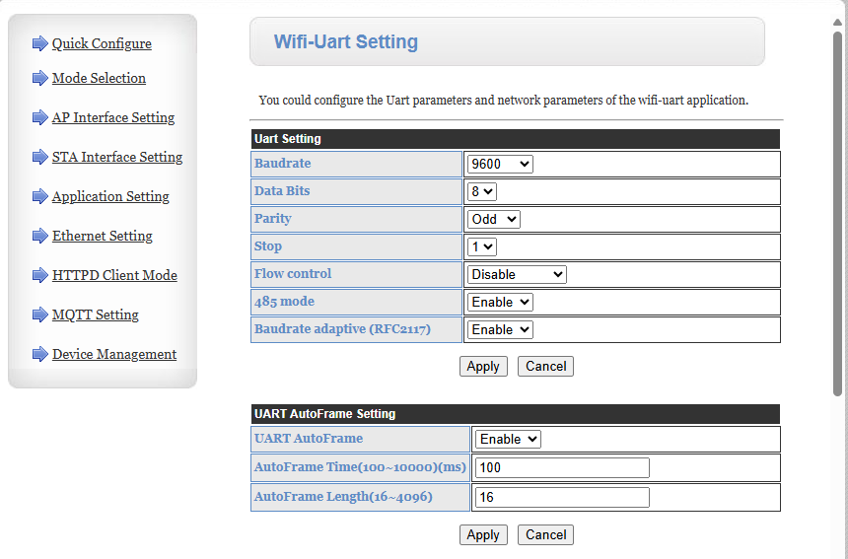
9.3.1 Enable UART AutoFrame : UART AutoFrame is a feature of the module that helps it to automatically group incoming UART bytes into packets (frames) before sending them over the network.
- AUTOFRAME TIME : If no new UART data arrives for 100 ms ( in this case), the module assumes:“ This frame is finished ”.
- AUTOFRAME LENGTH: Once 16 bytes (in this case) are received: The module immediately sends them as one frame.
9.3.2 To repeatedly retrieve the data in the register we use POLLING FUNCTION, in the USR-W610 there is inbuilt POLLING function called Heartbeat Function.

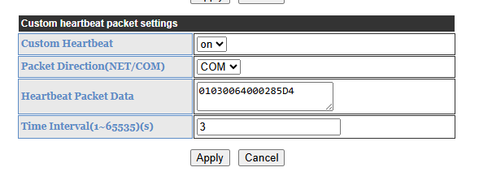
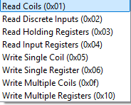
- Enable the custom Heartbeat
- Change the Packet Direction to COM
- To set the Heartbeat Packet Data :
01-slave id
03-Functionality (0x03)

00 64 – start register address.(00 64 means 100(register address) in hex)
00 02 – count of registers from start register(2 registers starting from 100 - 100,101)
85 D4 – is CRC (Cyclic Redundancy Check). To find CRC use online CRC tools. eg:crccalc.com ,in that website enter the hex values before the crc (010300640002) in the search bar and hit CRC-16 ,and search for MODBUS
The value obtained is reversed. That is 0xD485 is reversed to get 85 D4.

- Time interval is set to 3 s to poll for every 3s.
9.3.3 NETWORK A SETTINGS:
MODE: Change from server to client mode (server mode – devices connect to the USR ‘s TCP port ,client mode – USR connects to the Given SERVER address ).
Port: 1883 is the default port for unencrypted MQTT.
Server Address:broker.hivemq.com (public hivemq broker).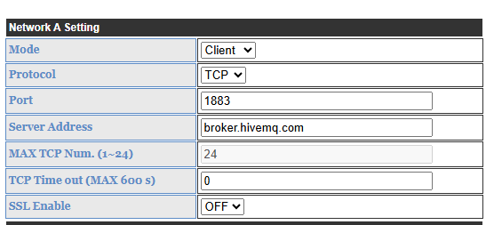

9.4 MQTT SETTINGS:

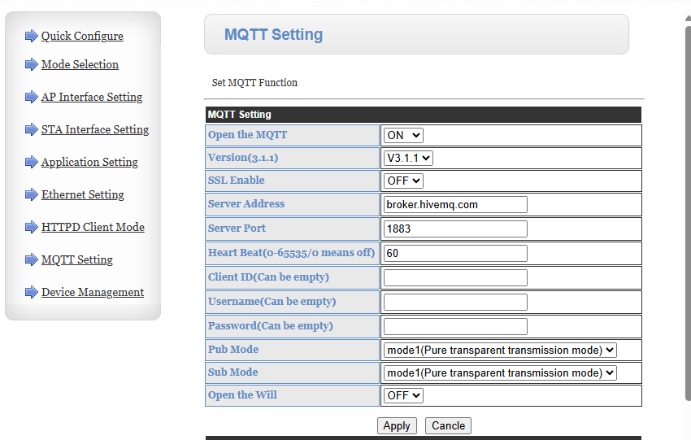

- Open the MQTT->ON
- Server address->broker.hivemq.com
- Server port->1883
- Leave username and password empty.(unless you have to use a username and password in the web-dashboard side).
- Keep the Pubmode and Submode in mode1.
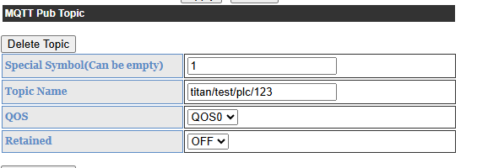
Set the topic name as used in code for the web-dashboard. Publish topic is a name assigned to the data we are going to send.

OUTPUT IN PYTHON-BASED DASHBOARD:

